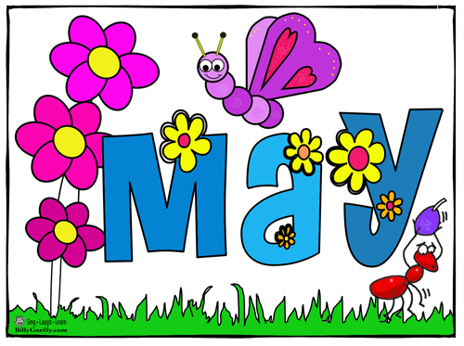
2022

Sunday | Monday | Tuesday |  | Wednesday | Thursday | Friday | Saturday
1 | 2 |  | 3 | 4 | 5 | 6 | 7
Provincial NBTA Day-
NO SCHOOL for students
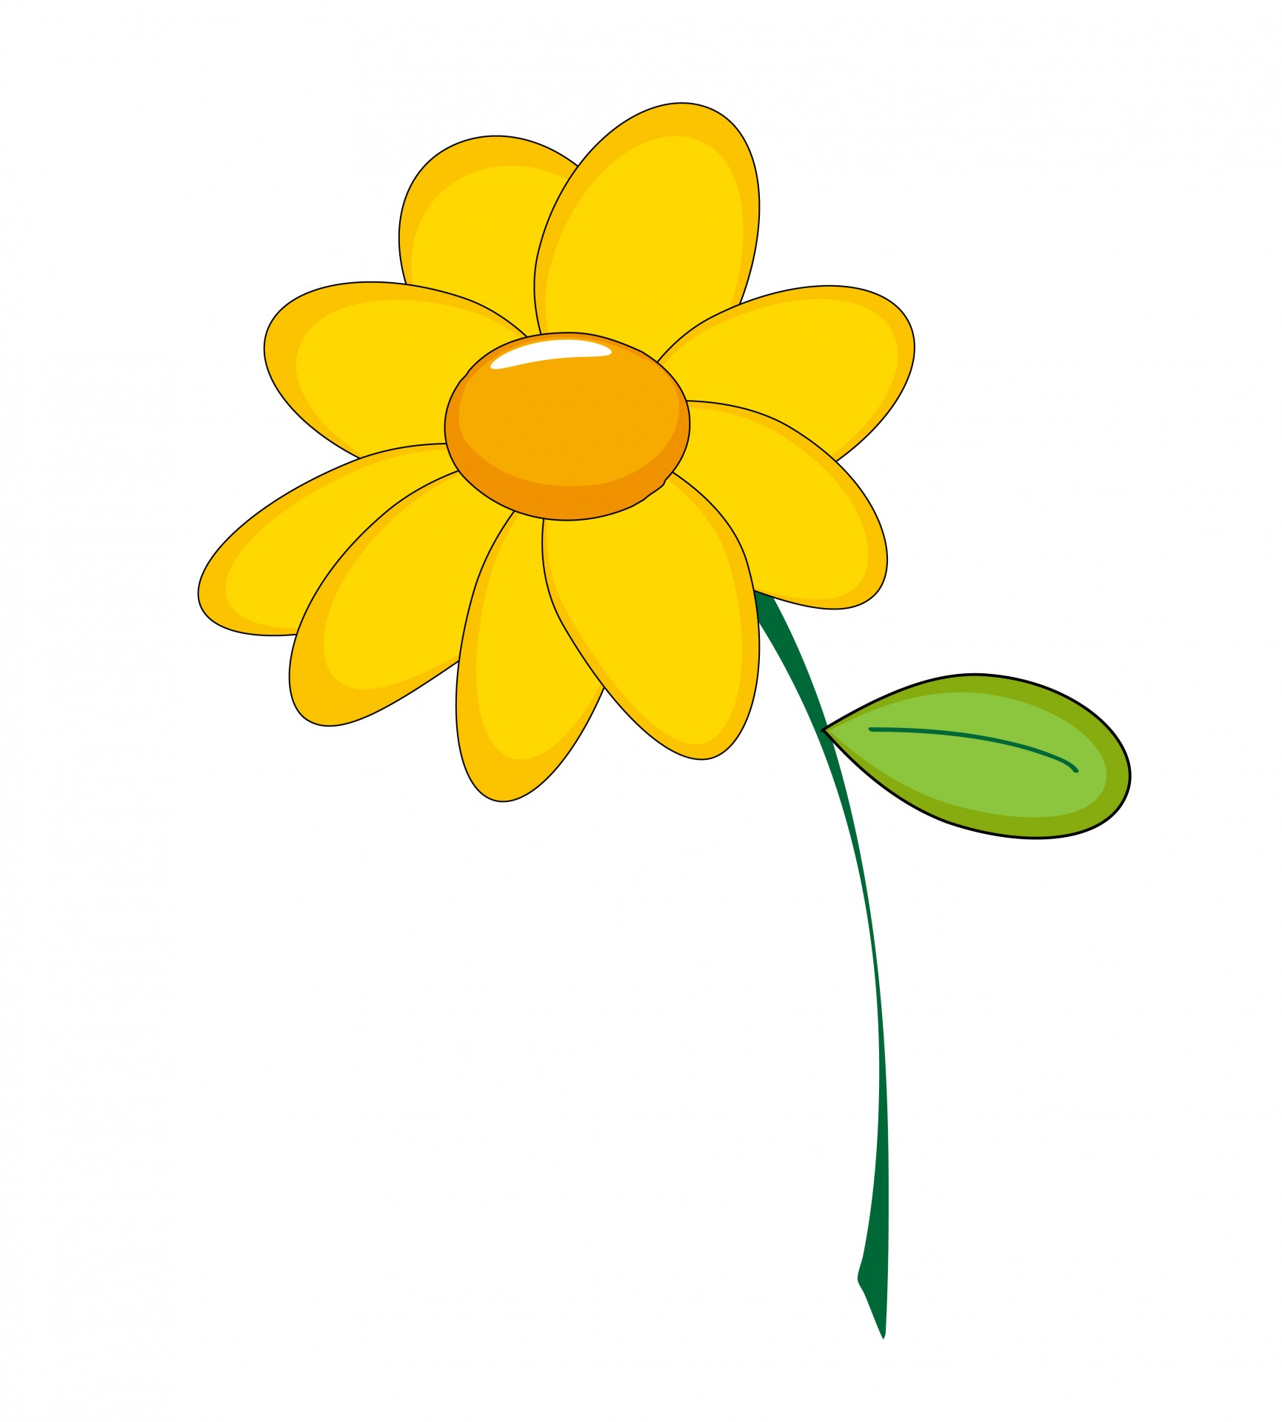  8 | 9 | 10 |  | 11 | 12 | 13 | 14
Mother’s
Day
15 | 16 | 17 |  | 18 | 19 | 20 | 21
 | NBTA/PD Day –  NO SCHOOL for students | PSSC meeting 6pm Online TEAMS
22 | 23 | 24 |  | 25 | 26 | 27 | 28
 | Victoria Day-  NO SCHOOL |  |  |  |  | Kindergarten 2022 Orientation
29 | 30 | 31
School Website:https://secure1.nbed.nb.ca/sites/ASD-W/Chipman/Pages/default.aspx

UNSCENTED PRODUCTS:
Please respect that we are a scent free environment when purchasing sunscreen, bug spray, etc. for usage at the school.

